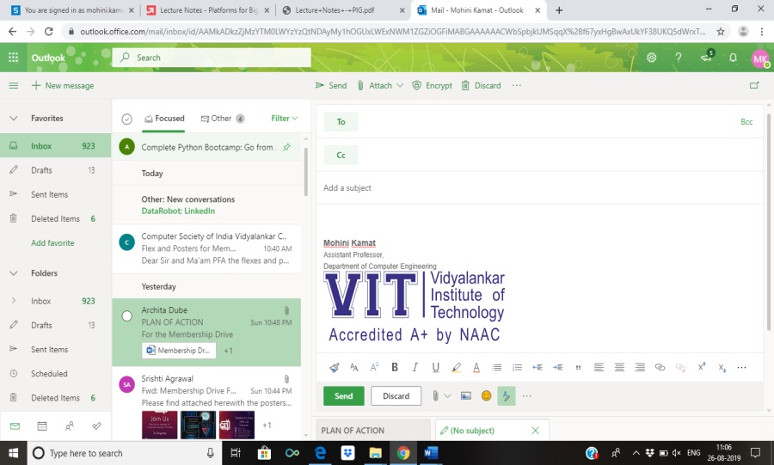
Semester | T.E. Semester VI – Computer Engineering
Subject | Mobile Computing
Subject Professor In-charge | Prof. Sneha Annappanavar
Assisting Teachers | Prof. Sneha Annappanavar
Laboratory | M310A

Student Name | Deep Salunkhe
Roll Number | 21102A0014
TE Division | A

Title:
Mobile Computing and Cloud

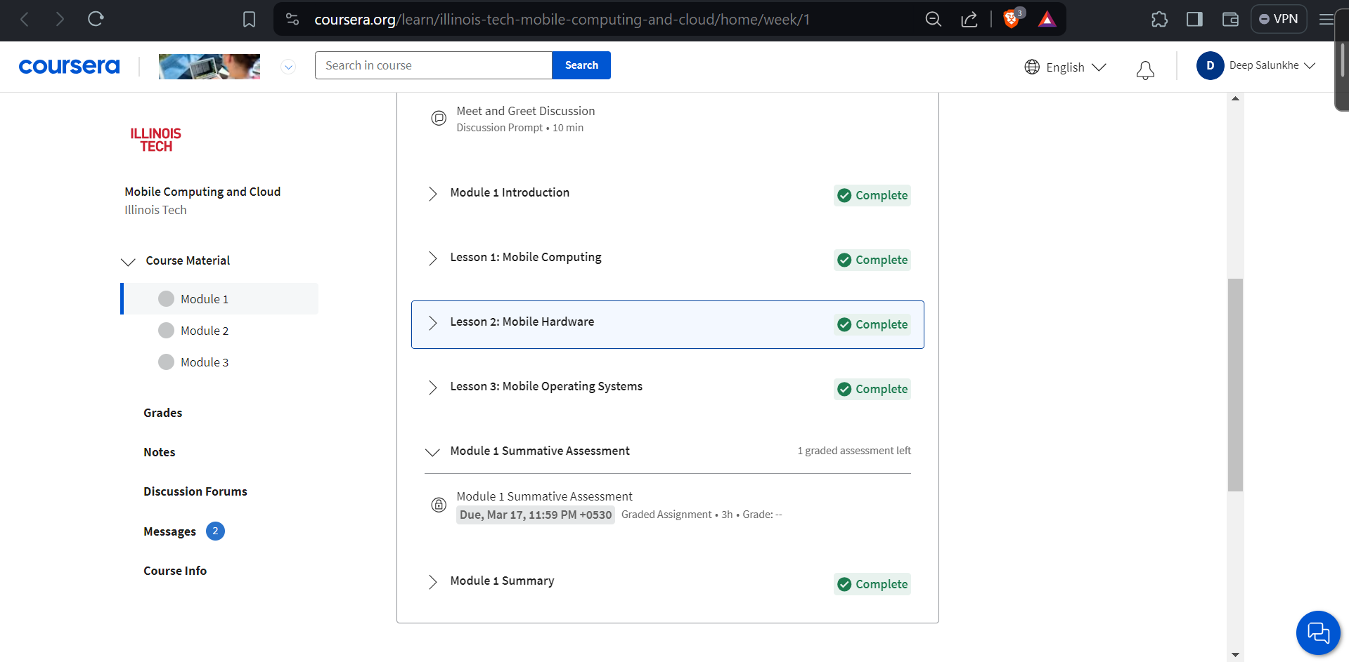

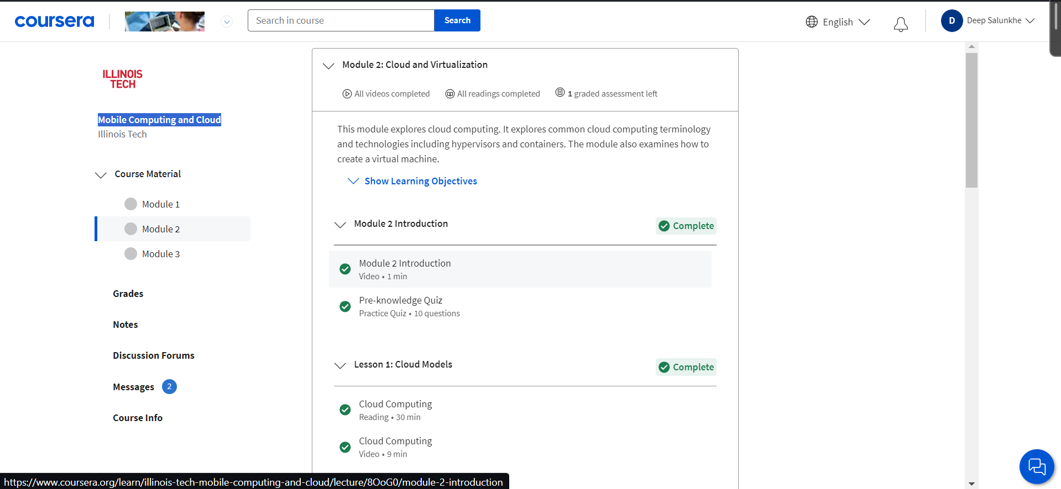

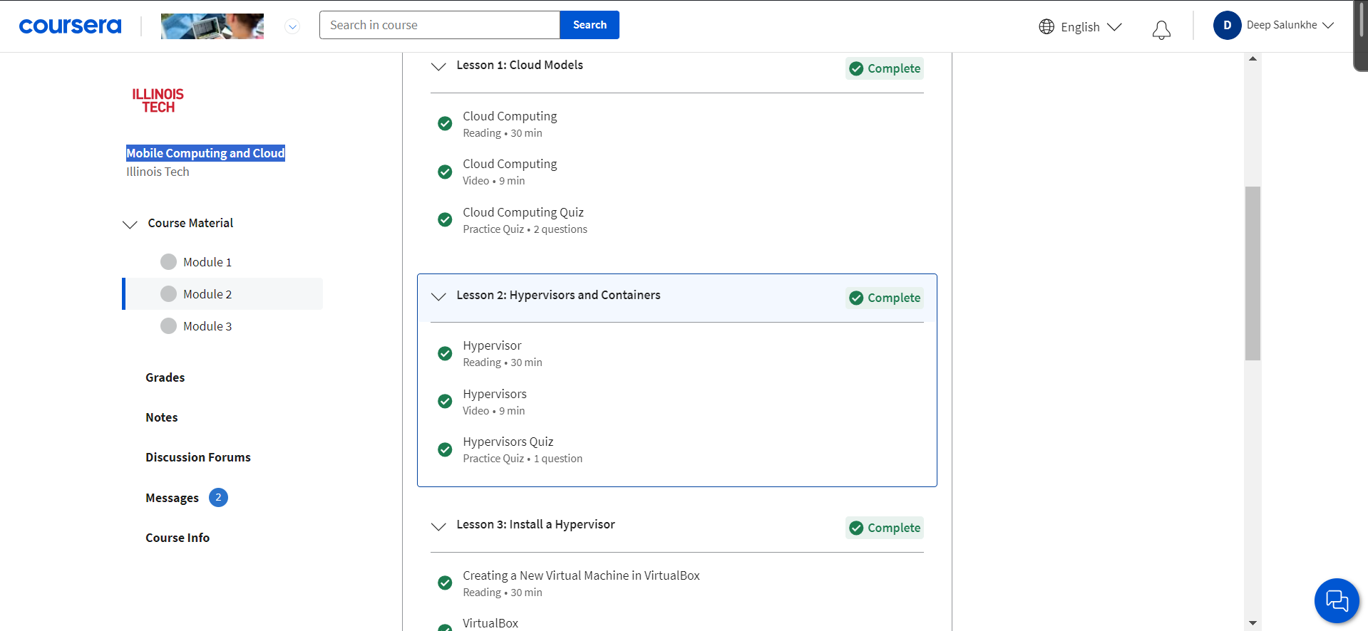

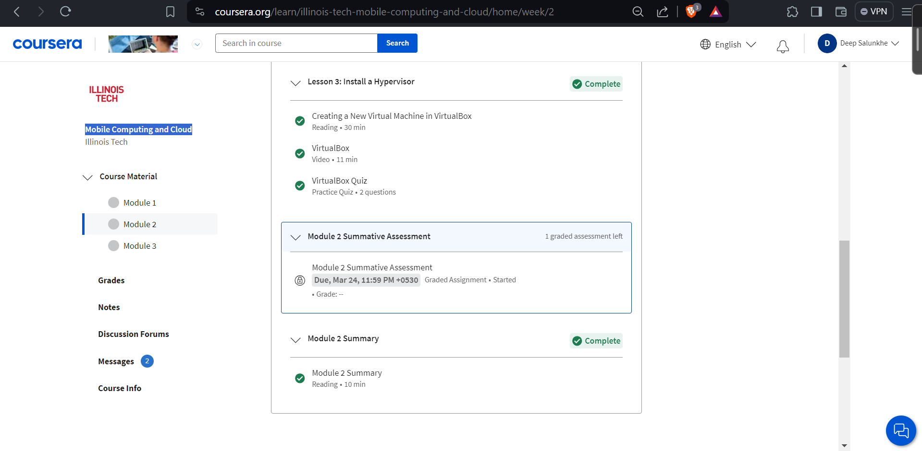

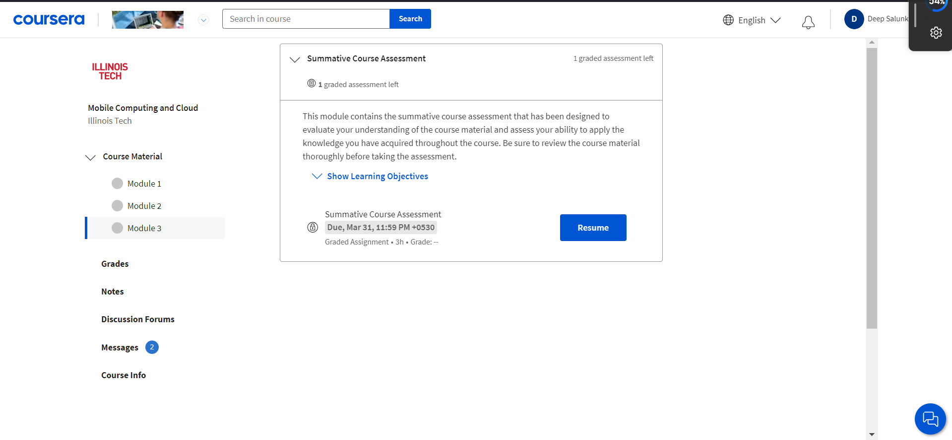

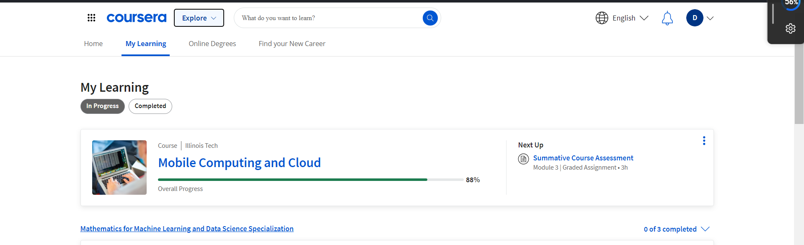

Conclusion:
In this course we got introduced to the world of cloud computing and cloud architecture we got to know how these two technologies work hand in hand, what are various OS for that are used in mobile devices, about security and privacy related concerns related to these technologies

